
RAMAIAH
Institute of Technology
USN | 1 | M | S

(Autonomous Institute, Affiliated to VTU)
(Approved by AICTE, New Delhi & Govt. of Karnataka) Accredited by NBA & NAAC with ‘A’ Grade

SEMESTER END EXAMINATIONS – JANUARY 2020

Program | : | B.E.: Electrical and Electronics Engineering | Semester | : | VII
Course Name | : | Power Systems - II | Max. Marks | : | 100
Course Code | : | EE72 | Duration | : | 3 Hrs

Instructions to the Candidates:
- Answer one full question from each unit.
- Suitably assume any missing data.

 |  | UNIT- I
1. | a) | Discuss the advantages of Y_{bus} over Z_{bus} in power system. | CO1 | (04)
 | b) | With a near sketch, model the equivalent circuit of transformer with off-nominal turns ratio used in formation of bus admittance matrix. | CO1 | (06)
 | c) | Form the for the power system shown in fig. 1(c) using building algorithm. Select ground node as reference. The line reactances are in PU. Connect the elements in the order  0-1, 1-2, 2-0 and 2-3.  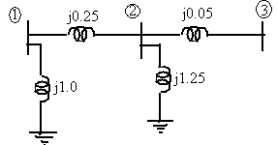  Fig.1(c) | CO1 | (10)
2. | a) | Form the bus admittance matrix by inspection for the system shown in fig. 2(a). All the impedances are in PU and off-nominal turns ratio a=0.95.  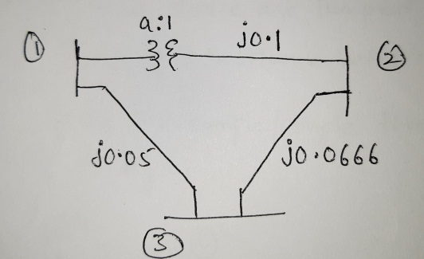  Fig.2(a) | CO1 | (10)
 | b) | The bus impedance matrix of a 6 node network with node 6 as reference is given below. Assuming the values as per unit reactances, find the topology of the network and parameters of the elements by using building algorithms  = j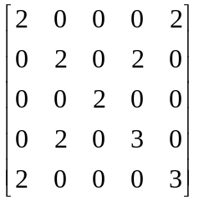 | CO1 | (10)
 |  | UNIT- II
3. | a) | Write the computational algorithm using Gauss-seidel method for the load flow analysis. | CO2 | (10)
 | b) | What are the different types of buses as categorized for load flow studies, explain briefly each one of them. | CO2 | (06)
 | c) | Compare the performance of Gauss-Seidel and Newton-Raphson methods for load flow solution. | CO2 | (04)
4. | a) | Determine the voltages at the end of first iteration using Gauss Seidal method. Assume V=1PU for all PQ buses. The system data is given below. | CO2 | (14)
  LINE DATA
  LINE No. | BUS CODE | SERIES LINE IMPEDANCEIN PU
  1 | 1-2 | 0.05 + j 0.15
  2 | 1-3 | 0.10 + j 0.30
  3 | 2-3 | 0.15 + j 0.45
  4 | 2-4 | 0.10+ j 0.30
  5 | 3-4 | 0.05 +j 0.15
  BUS DATA
  BUS | GENERATION IN PU |  | LOAD IN PU |  | V
  BUS | PG | QG | PL | QL | V
  1 | - | - | - | - | 1.04 +J 0
  2 | 1.5 | 1 | 1 | 1.2 | -
  3 | 2 | 2 | 3 | 1.5 | -
  4 | 1 | 0.5 | 0.7 | 0.6 | -
 | b) | List the data essential for the load flow? | CO2 | (06)
 |  | UNIT- III
5. | a) | The fuel costs of three thermal plants in $/hr is given by  F1 = 350 + 7.2 P₁ + 0.004 P₁²  F2 = 500 + 7.3 P₂ + 0.0025 P₂²  F3= 600 + 6.74 P₃ + 0.003 P₃²  Find the optimal schedule for a demand of 600 MW and also determine the system incremental fuel cost. | CO3 | (07)
 | b) | A two bus system has generators connected to both buses and a load only at bus 2. If 150 MW is transmitted from bus 1, a loss of 18MW is incurred. When the system incremental fuel cost λ = 32Rs/MWh find P1, P2, Ploss and power received by load if  dF1/dP1 = 0.025 P1 + 18.0 Rs/MWh  dF2/dP2 = 0.5 P2 + 22.0 Rs/MWh | CO3 | (07)
 | c) | Discuss the difference between unit commitment and economic dispatch problems. What are the constraints in solving for unit commitment? | CO3 | (06)
6. | a) | How are losses in the transmission system accounted for in the B coefficients. Derive expression for the B coefficients. | CO3 | (07)
 | b) | Compute the loss coefficients for the system shown in Fig. 6(b) given the following data.  Ia = 1.0+j0.0 pu; Ib = 0.8+j0.0pu; Ic = 1.0+j0.0 pu  Za= 0.04+j0.16pu; Zb = 0.03+j0.12pu ;Zc = 0.02+j0.08 pu.  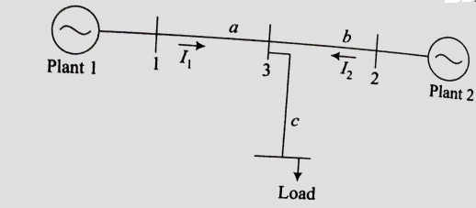  Fig.6(b) | CO3 | (08)
 | c) | Derive expression for the penalty factor and show how it can be interpreted to infer the system performance. | CO3 | (05)
 |  | UNIT- IV
7. | a) | Explain point by point method for solving swing equation. | CO4 | (10)
 | b) | For the swing equation, 0.0331d²δ/dt²=0.8-1.333sinδ. Determine the values of δ and ω at the end of 0.05 sec by taking a step of 0.05sec. Given δ₀ = 0.756, ω₀=2.067. Use Runge-Kutta method. | CO4 | (10)
8. | a) | Explain the modified Euler’s method used in the solution of swing equation under transient stability studies. | CO4 | (10)
 | b) | Illustrate clearly the steps involved in solving swing equation using Runge- Kutta method for transient analysis. | CO4 | (10)
 |  | UNIT- V
9. | a) | Two generators rated at 250MW and 500MW are operating in parallel. The droop characteristics of their governors are 4% and 5% from no load to full load. If the nominal frequency is 50Hz at no load, how would a load of 750MW be shared between them? What is the system frequency? | CO5 | (08)
 | b) | What is the need for compensators in power system? Explain any one type of Static VAR compensator. | CO5 | (08)
 | c) | Write brief note on FACTS controllers. | CO5 | (04)
10. | a) | Discuss the need for load-frequency control in power system. | CO5 | (06)
 | b) | Draw the conventional Governor model and discuss the functions of major parts of it. | CO5 | (08)
 | c) | A 500 MVA synchronous generator operates on full load at frequency of 50 Hz. The load is suddenly reduced to 400 MW. Due to time lag in governor system, the steam valve beings to close after 0.5 seconds. Determine the change in frequency that occurs in this time if H=5kW-sec/kVA of generator capacity. | CO5 | (06)
****************

